<!DOCTYPE html>

<html>

<head>

<title>Tiger Face</title>

<link rel="stylesheet" type="text/css" href="tig.css">

</head>

<body>

<div class="tiger-face">

<div class="eye left-eye"></div>

<div class="eye right-eye"></div>

<div class="nose"></div>

<div class="mouth"></div>

<div class="whiskers">

<span class="whiskers left-whiskers"></span>

<span class="whiskers right-whiskers"></span>

</div>

<div class="ear left-ear"></div>

<div class="ear right-ear"></div>

</div>

</body>

</html>

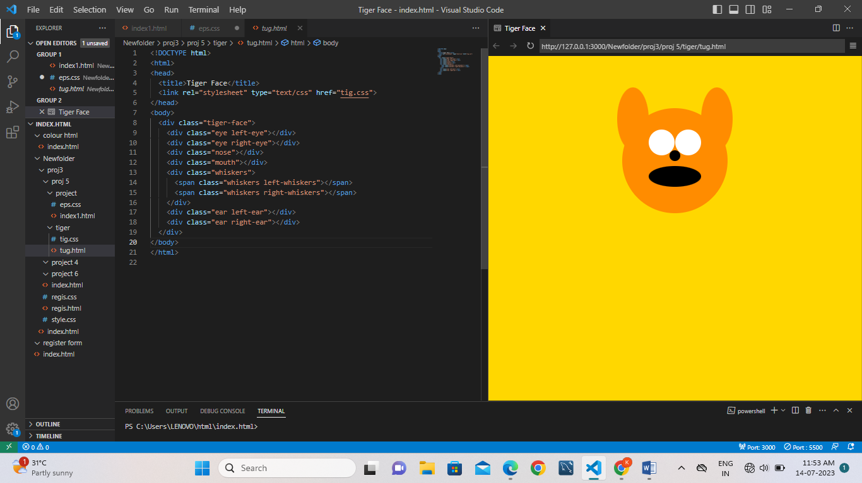

body {

background-color: #FFD700; /\* Set background color to gold \*/

}

.tiger-face {

position: relative;

width: 200px;

height: 200px;

background-color: #FF8C00; /\* Set face color to dark orange \*/

border-radius: 50%;

margin: 100px auto;

}

.eye {

position: absolute;

width: 50px;

height: 50px;

background-color: white;

border-radius: 50%;

top: 40px;

}

.left-eye {

left: 50px;

}

.right-eye {

right: 50px;

}

.nose {

position: absolute;

width: 20px;

height: 20px;

background-color: black;

border-radius: 50%;

top: 80px;

left: 90px;

}

.mouth {

position: absolute;

width: 100px;

height: 40px;

background-color: black;

border-radius: 50px/20px;

top: 110px;

left: 50px;

}

.whiskers {

position: absolute;

top: 80px;

left: 10px;

}

.whisker {

position: absolute;

width: 70px;

height: 2px;

background-color: black;

}

.left-whisker {

top: 10px;

transform: rotate(20deg);

}

.right-whisker {

top: 10px;

transform: rotate(-20deg);

}

.ear {

position: absolute;

width: 60px;

height: 120px;

background-color: #FF8C00; /\* Set ear color to dark orange \*/

border-radius: 50%;

top: -40px;

}

.left-ear {

left: -10px;

}

.right-ear {

right: -10px;

}

